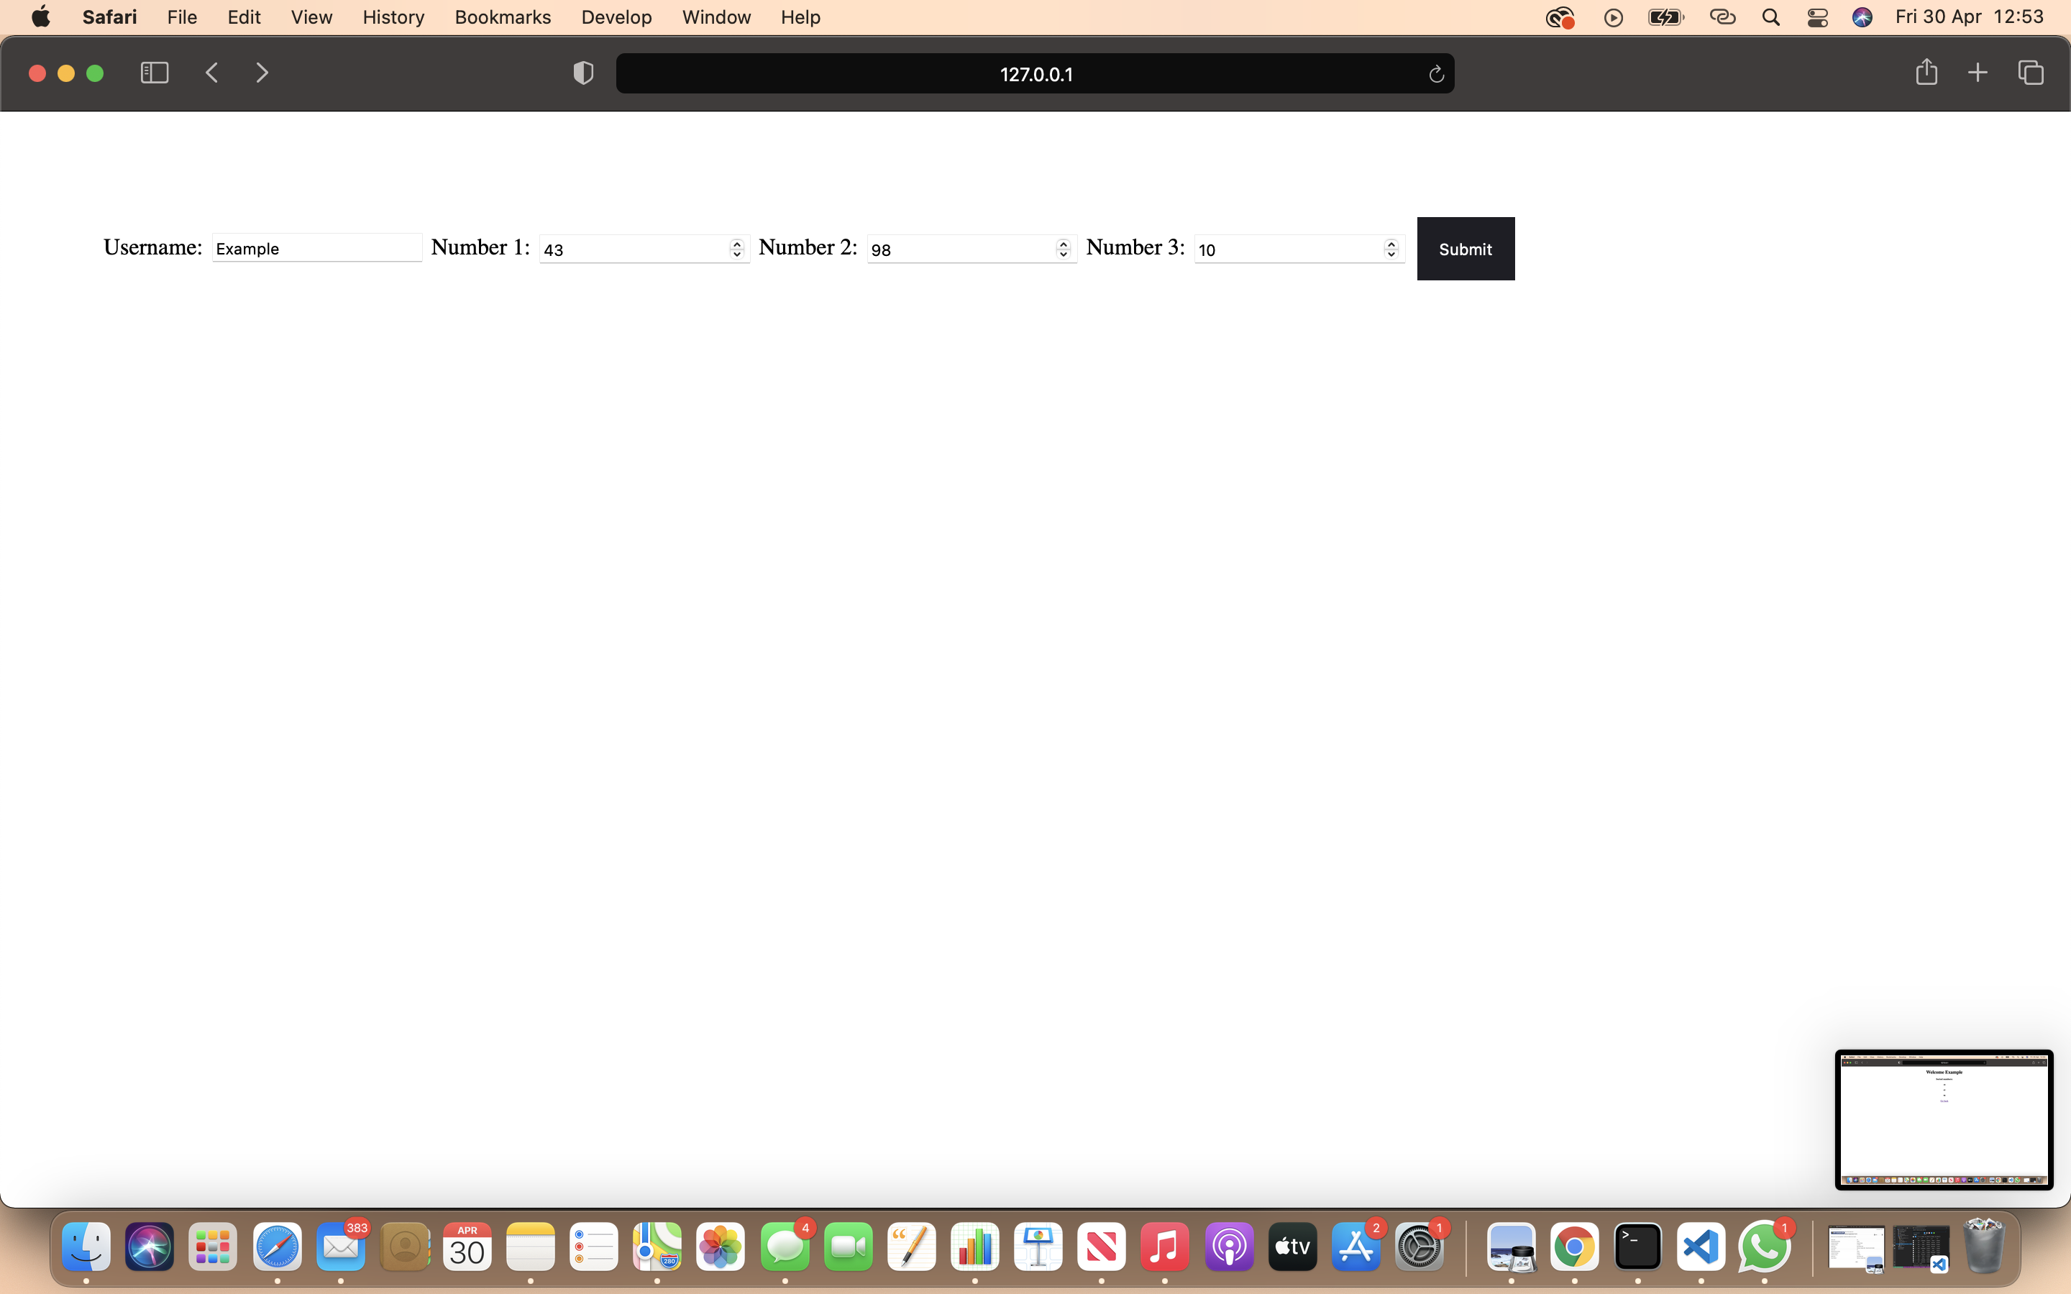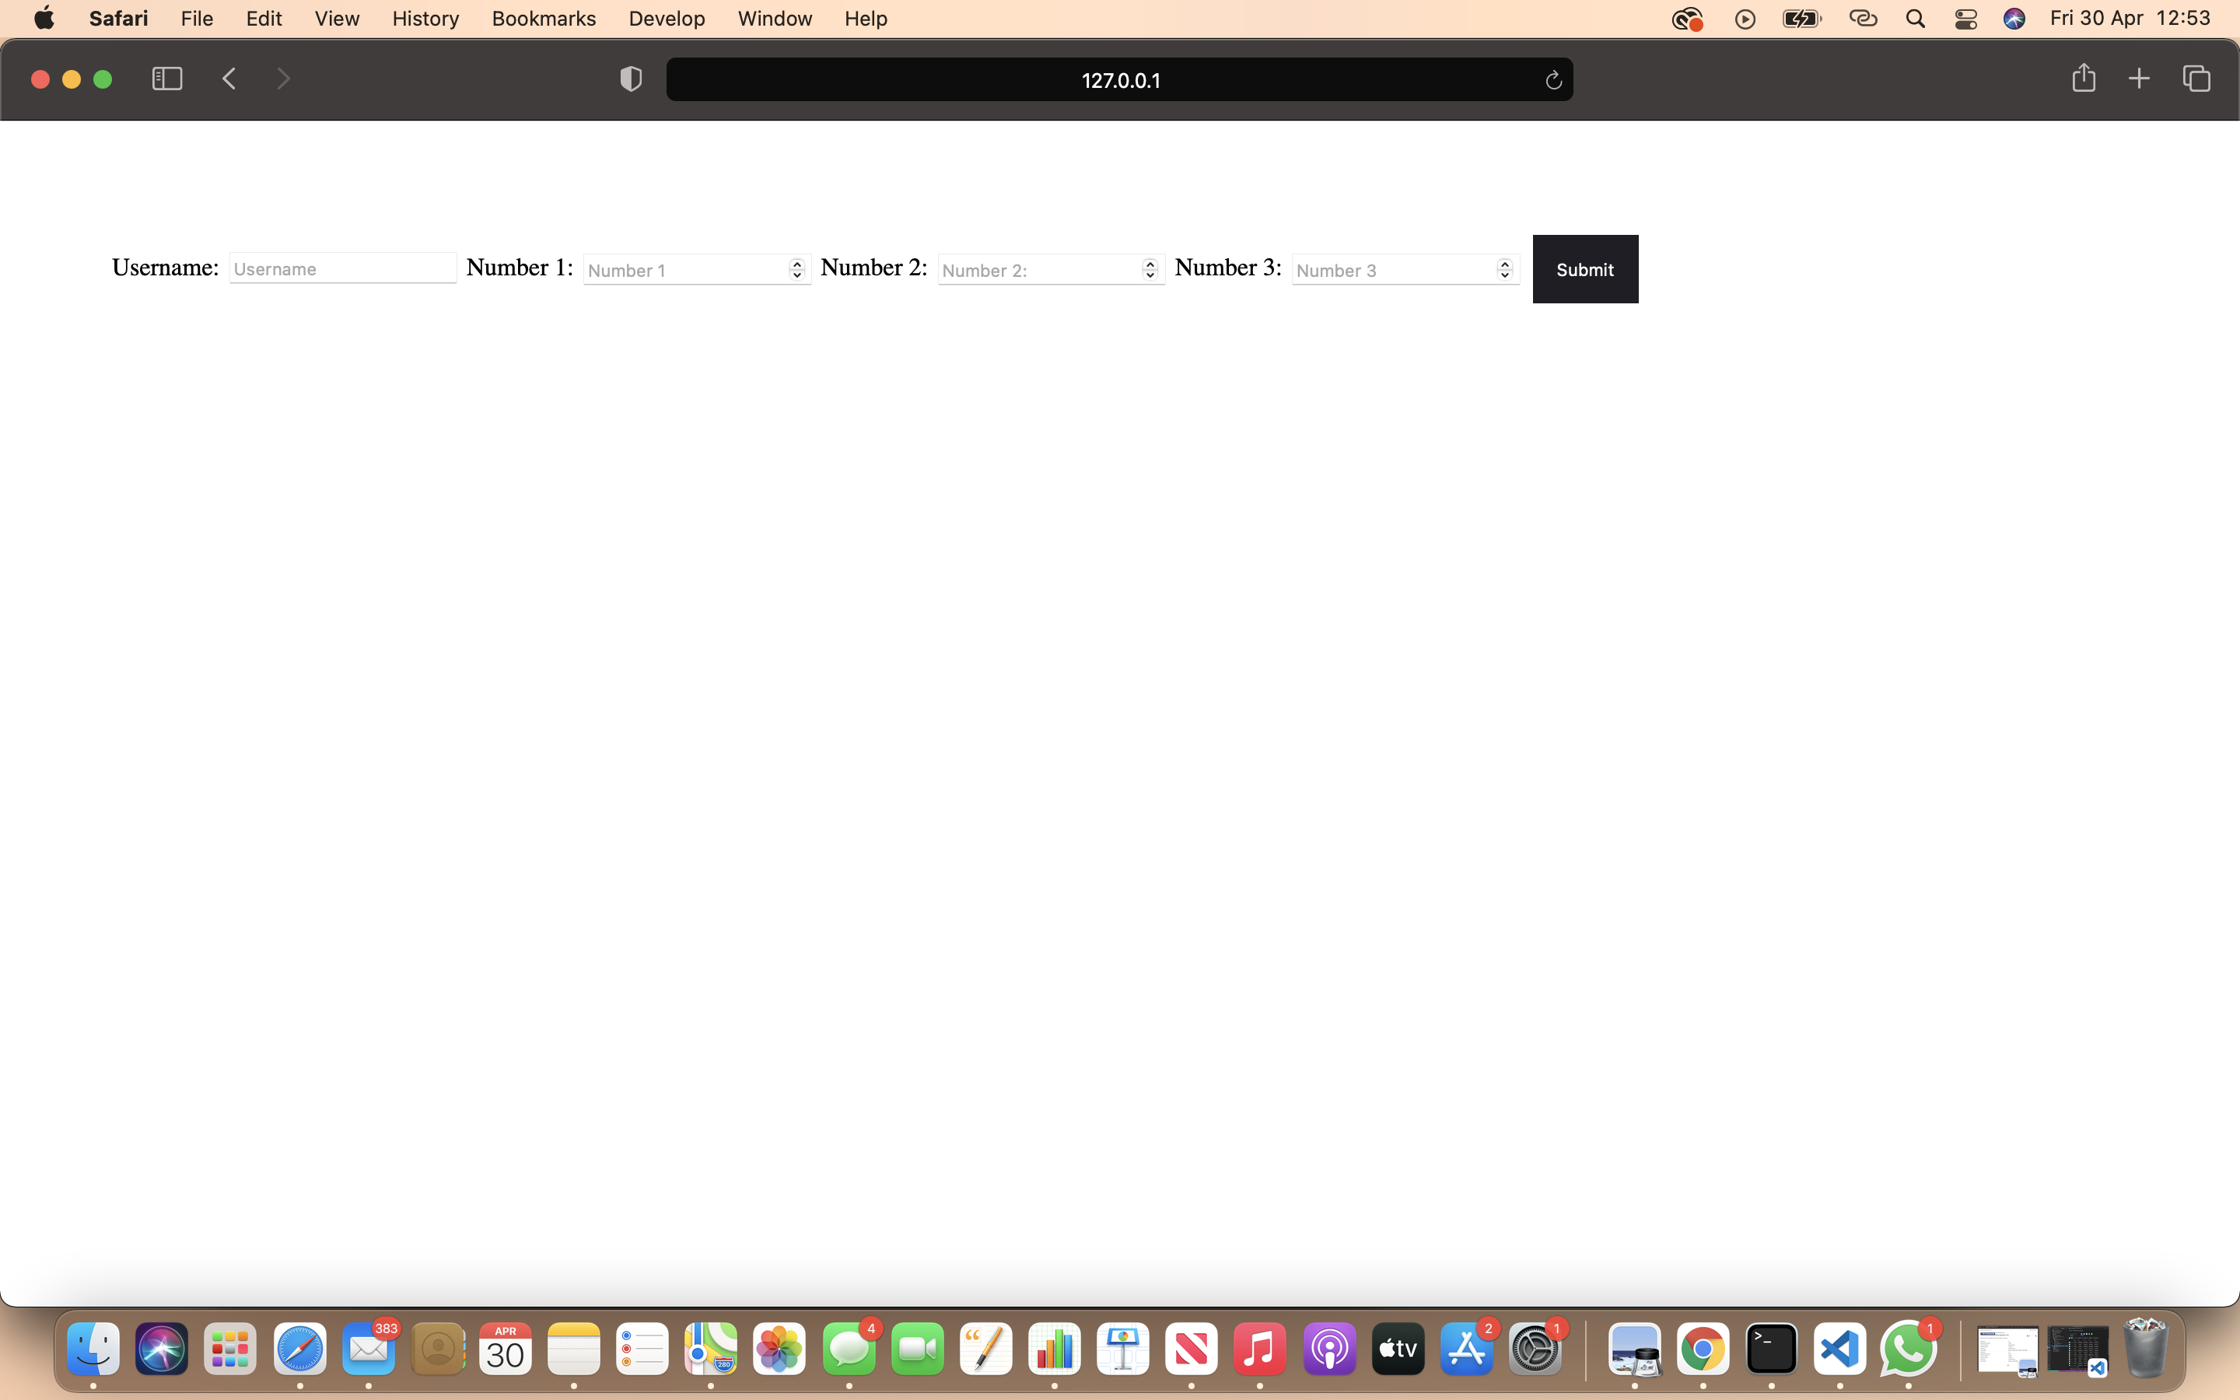

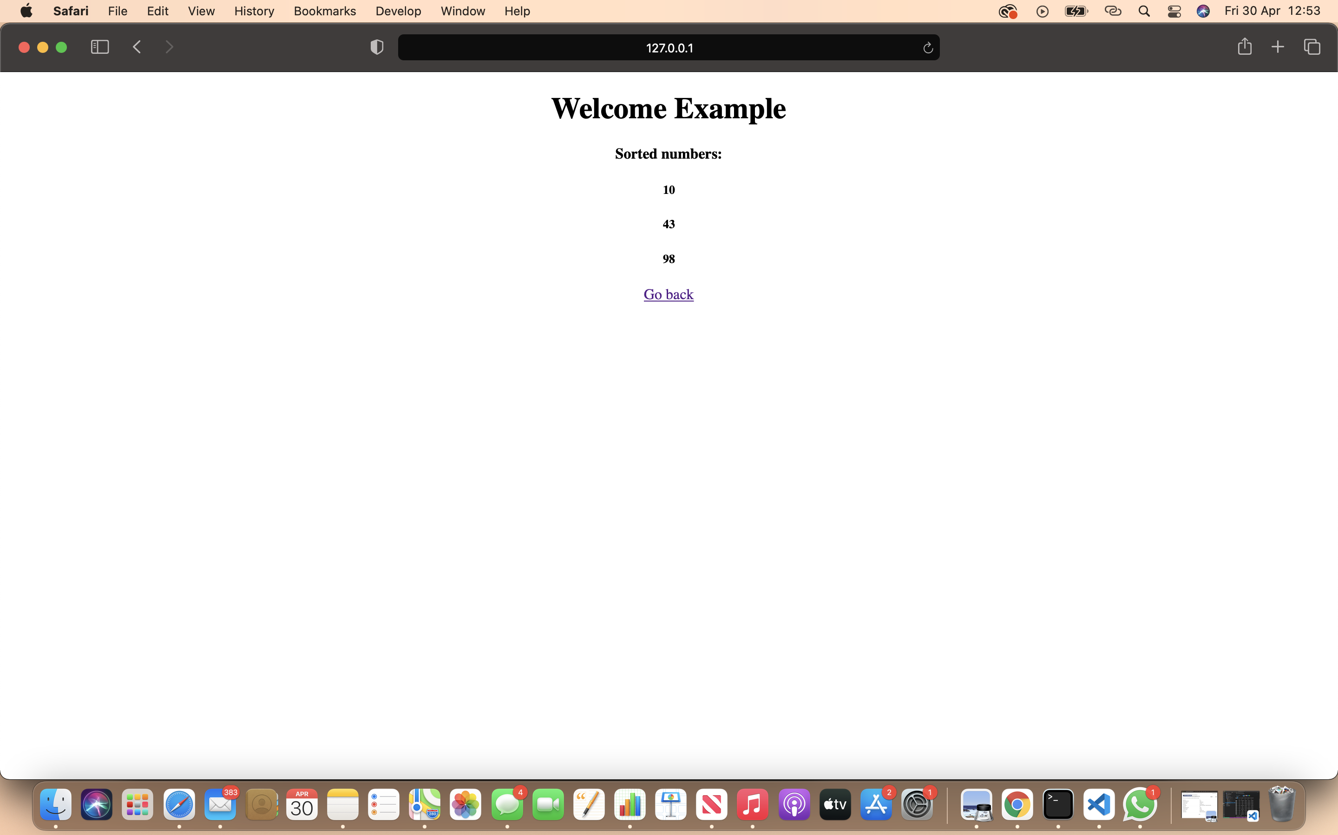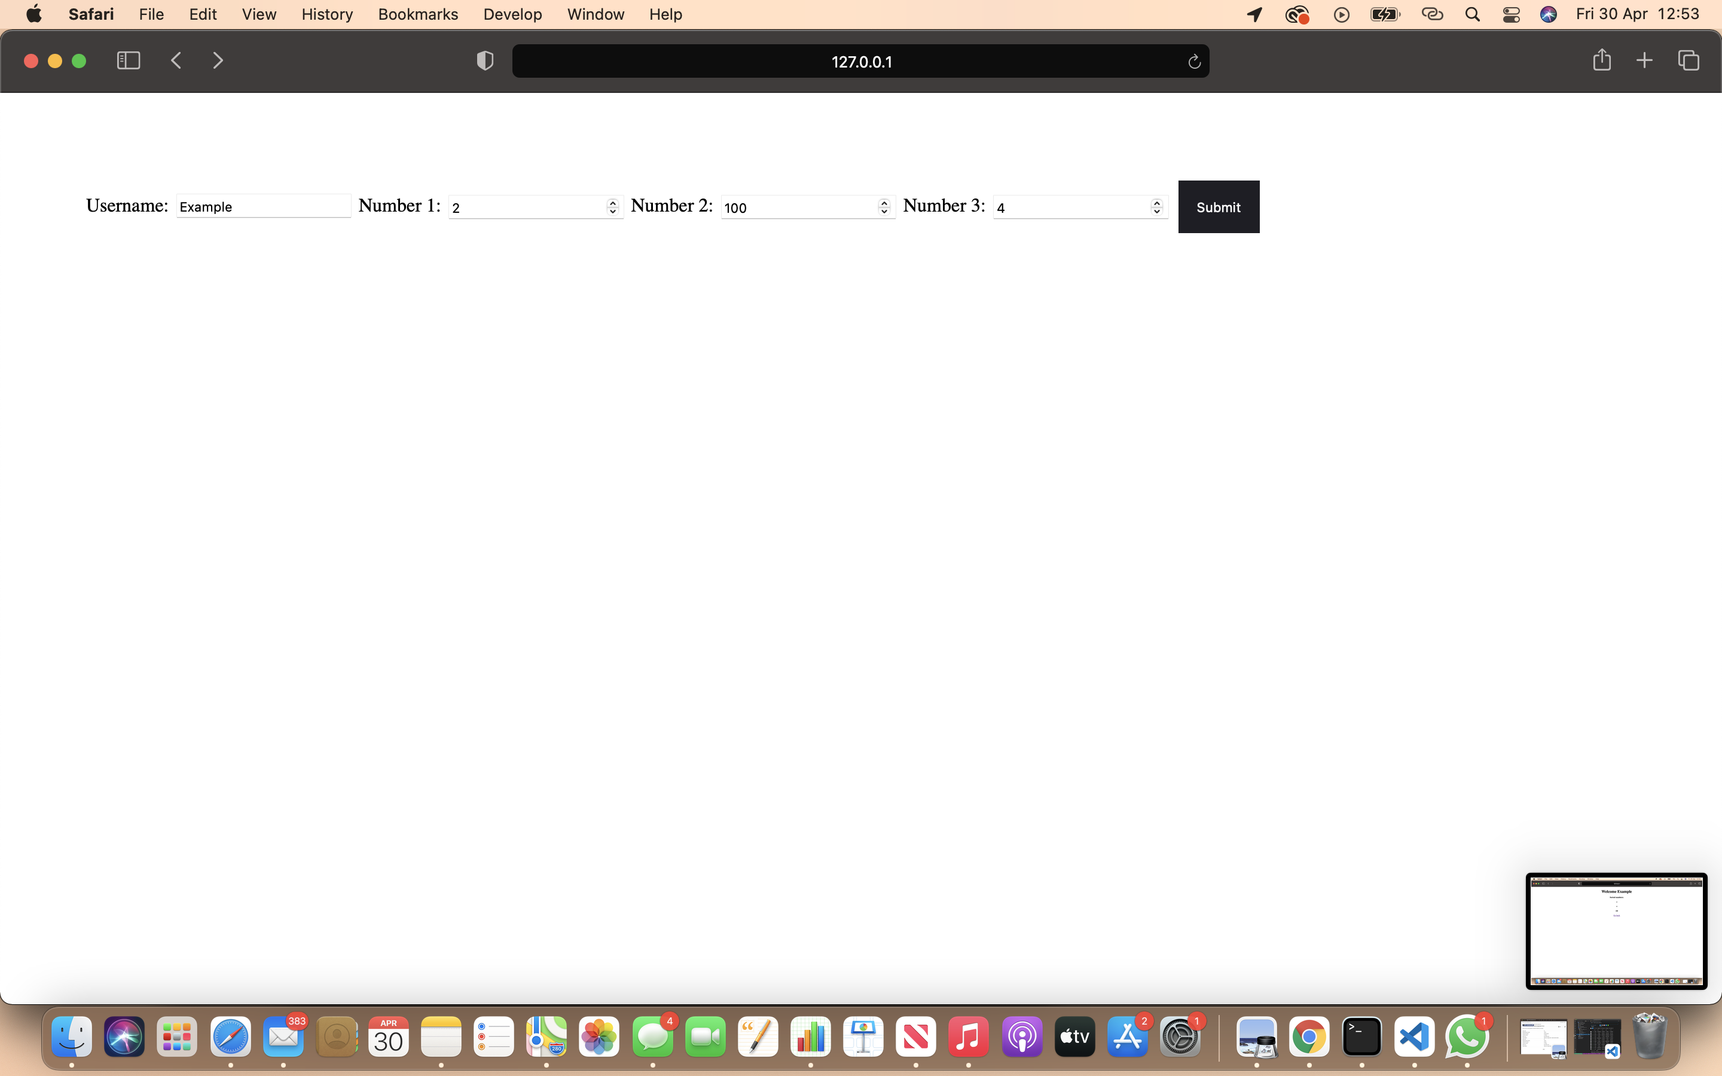

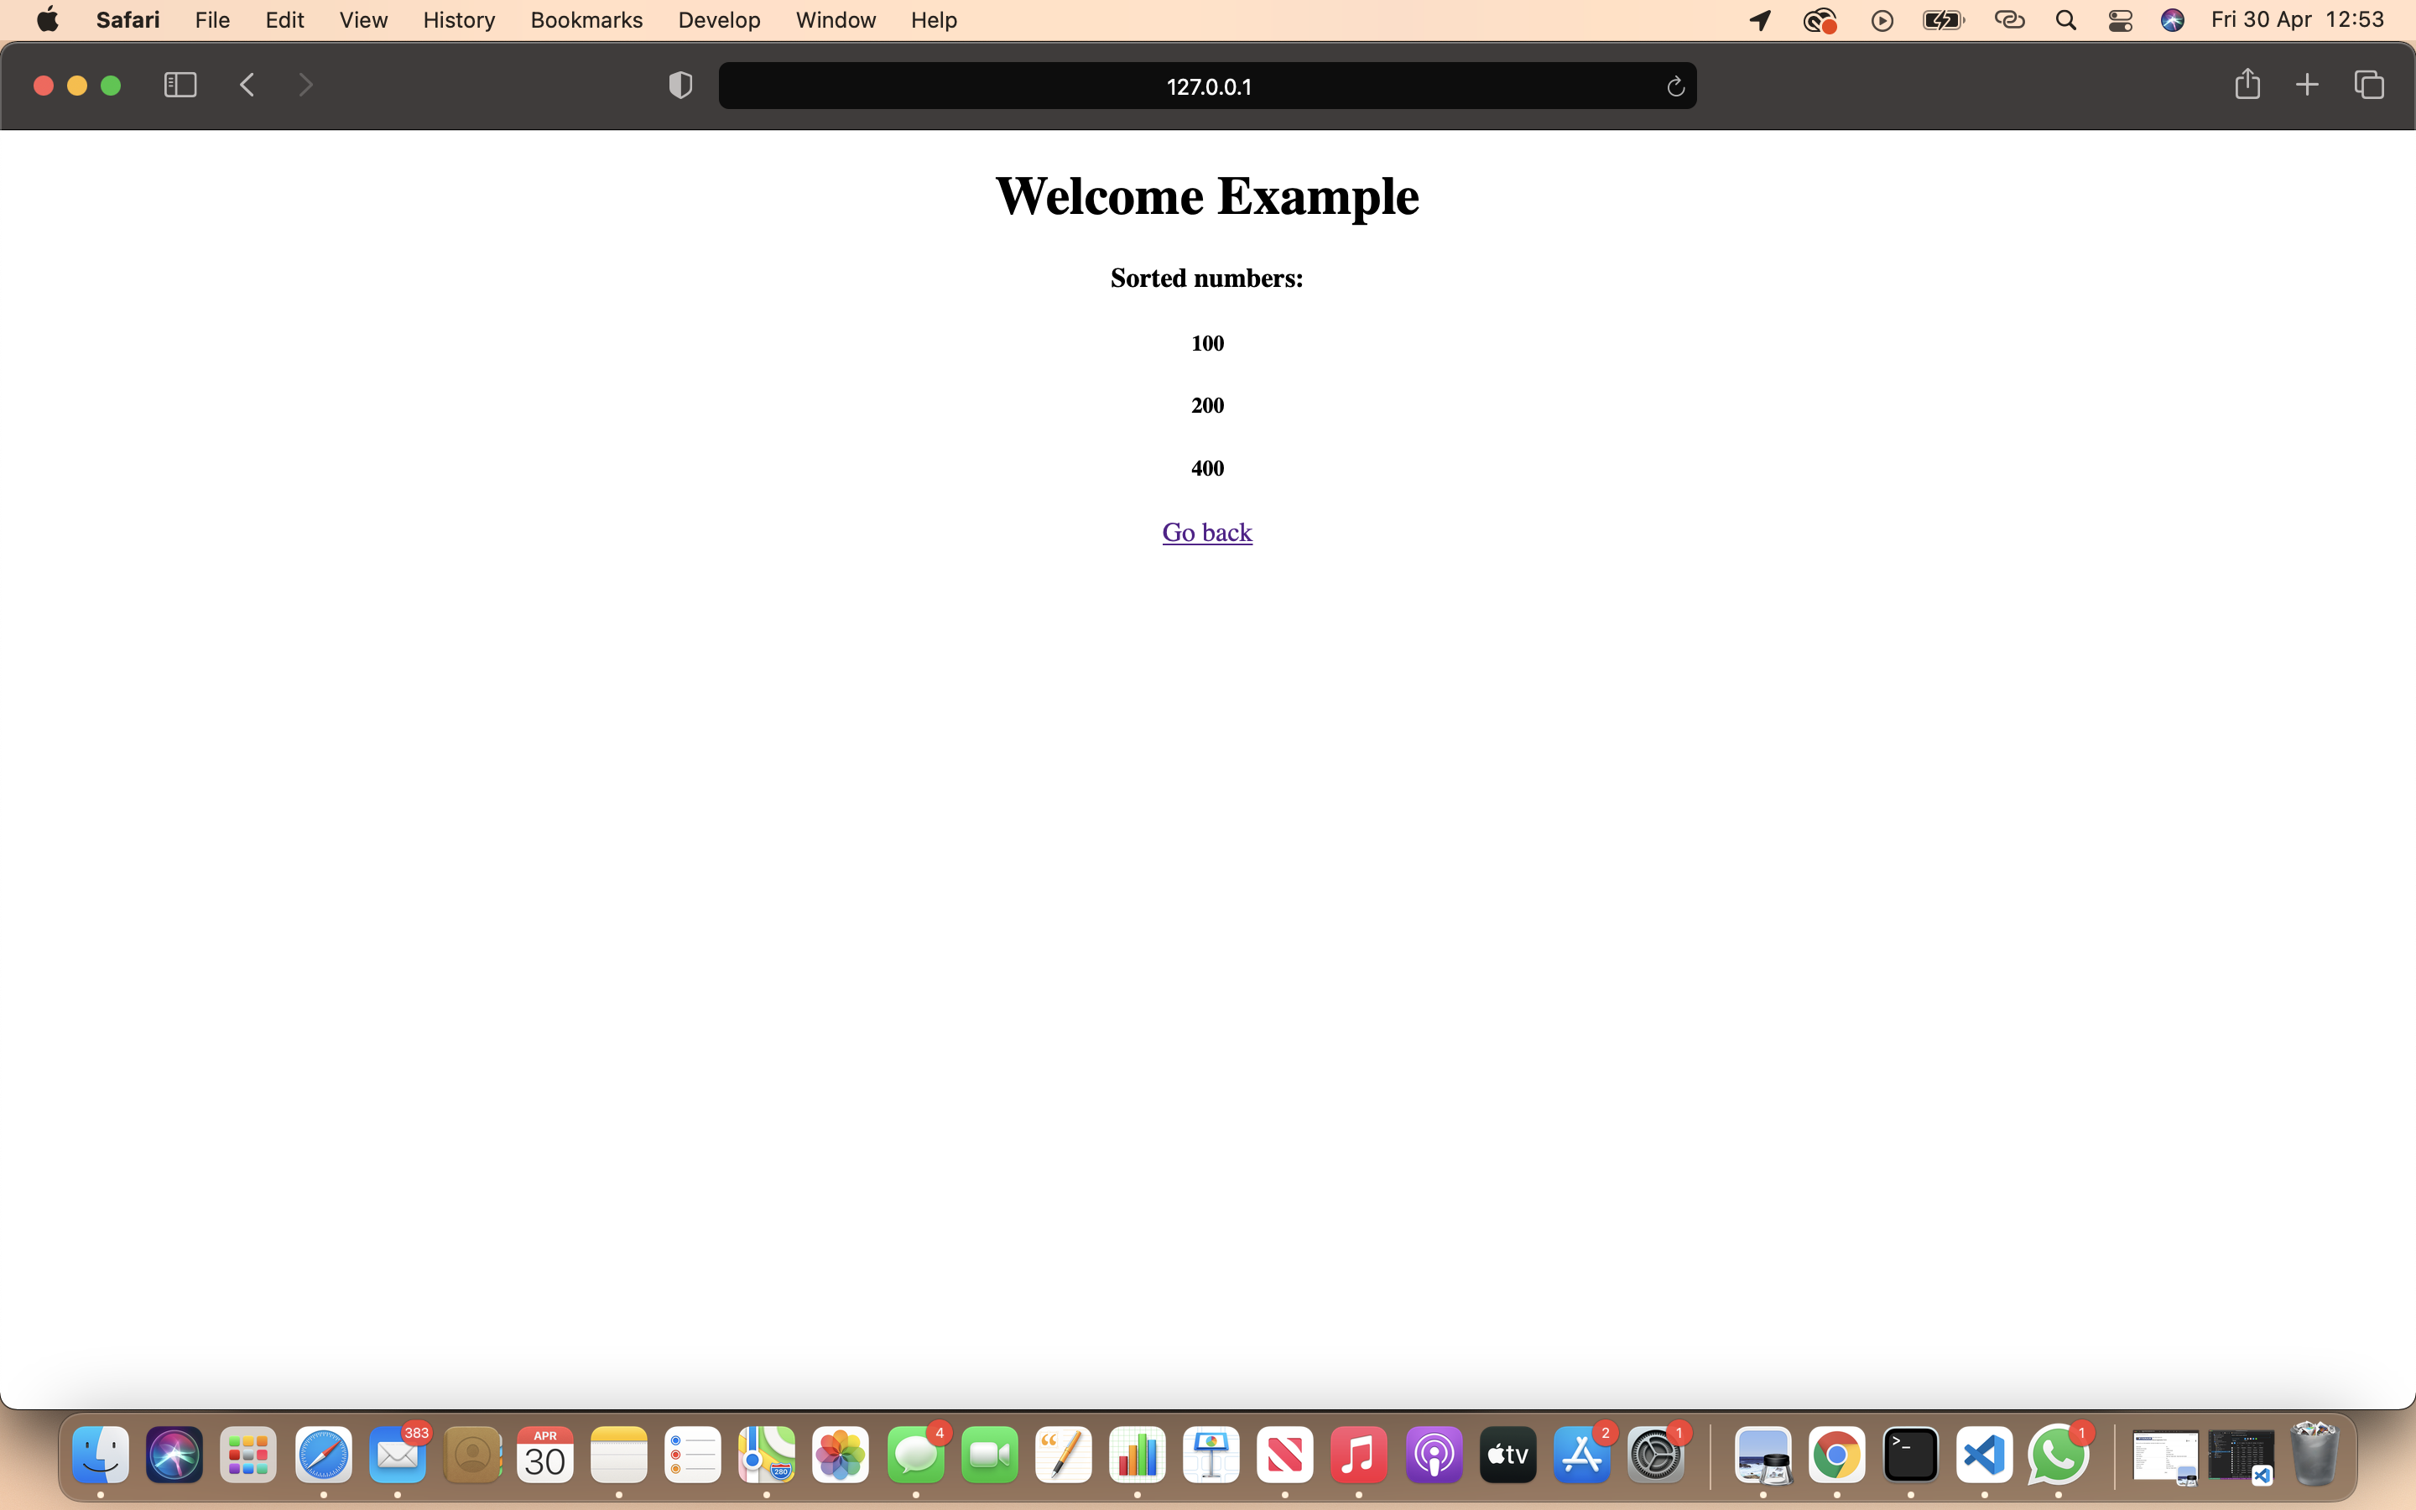

**RUNNING THE CODE:** In order to run this code, the user will need to start the application. The homepage will open. The homepage has inputs which have to be filled in order to move to the next page. The next page will display the username and the numbers inputted by the user. The numbers will be displayed sorted.

